|  |  |
| --- | --- |
| **NAME:** | Dewyani Anil Deshmukh |
| **UID:** | 2021300024 |
| **CLASS:** | SE Comps-A |
| **EXPERIMENT NO:** | 1-b |

**AIM**: Finding the running time of insertion sort and selection sort algorithms.

**ALGORITHM:**

**Insertion sort**

* Iterate from arr[0] to arr[size-1] over the array.
* Compare the current element (key) to its predecessor.
* If the key element is smaller than its predecessor, compare it to the elements before. Move the greater elements one position up to make space for the swapped element.

**Selection sort**

* Run a for loop using i variable to traverse through the array.
* Assign i to min .
* Again run a for loop using j variable to traverse through the array.
* This time while traversing if the element is smaller than the element at min location(a[min]) then assign min the value of that new index( j).
* After the second for loop ends, swap the elements a[i] and a[min]

**CODE:**

**Generating 100000 numbers:**

#include <stdio.h>

#include <stdlib.h>

int main()

{

    int num,offset=0;

    int i,j;

    FILE *fptr;

    fptr=fopen("numbers.txt","w");

    for(i=0; i<1000; i++)

    {

        for (j= 0; j<100; j++)

        {

           num = rand() % 100 + offset;

           fprintf(fptr," %d ",num);

        }

        offset+=100;

    }

    fclose(fptr);

    return 0;

}

**Sorting algorithms:**

#include <stdio.h>

#include <stdlib.h>

#include <time.h>

void selectionSort(int a[], int len)

{

    int min,temp;

    int i,j,key;

    for(i=0; i<len-1; i++)

    {

        min=i;

        for(j=i+1; j<len; j++)

        {

            if(a[j]<a[min])

            {

                min=j;

            }

        }

        temp=a[i];

        a[i]=a[min];

        a[min]=temp;

    }

}

void insertionSort(int arr[],int size){

    int i;

    int j;

    int key;

    for(int i=0;i<size;i++){

        key=arr[i];

        j=i-1;

        while(j>=0&&arr[j]>key){

            arr[j+1]=arr[j];

            j--;

        }

        arr[j+1]=key;

    }

}

int main(){

FILE *file = fopen("numbers.txt", "r");

    int integers[100000];

    int i=0;

    int num;

    while(fscanf(file, "%d\t", &num) > 0) {

        integers[i] = num;

        i++;

    }

    fclose(file);

    for (int i = 0; i < 1000; i++)

    {

        int integers1[100*(i+1)];

        int integers2[100*(i+1)];

    for(int j=0;j<100*(i+1);j++){

        integers1[j]=integers[j];

        integers2[j]=integers[j];

    }

    clock_t launch=clock();

    selectionSort(integers1,100*(i+1));

    clock_t done=clock();

    double stime=((double)done-launch)/CLOCKS_PER_SEC;

    clock_t launch2=clock();

    insertionSort(integers2,100*(i+1));

    clock_t done2=clock();

    double itime=((double)done2-launch2)/CLOCKS_PER_SEC;

    printf("%d\t%0.3f\t",i+1,stime);

    printf("%0.3f\n",itime);

    }

    return 0;

}

**GRAPHICAL REPRESENTATION:**

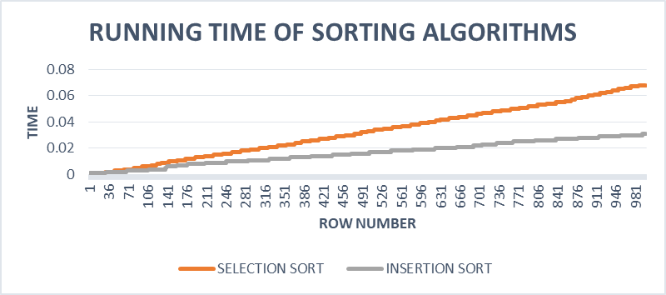

**OBSERVATIONS:**

1. From the graph it can be observed that insertion sort is faster than selection sort.
2. The space complexity for both the algorithms is same i.e O(1).

**CONCLUSION:** I have successfully implemented both the sorting algorithms and have analysed their time and space complexity.